

VISVESVARAYATECHNOLOGICALUNIVERSITY

JnanaSangama, Belagavi, Karnataka- 590018

AMINI PROJECTREPORT

ON

LIBRARYMANAGEMENTSYSTEM

SUBMITTEDBY:

NIKITHKUMARN(1RI17CS028)

Undertheguidanceof

Prof. MalaP

AssistantProfessor, Dept. ofCSE

Department of Computer ScienceandEngineering

R.R. Institute of Technology

Bangalore, Karnataka, India–560090

November 2019- 20



RRINSTITUTEOFTECHNOLOGY

No. 67, RajaReddylayout, HesaraghattaMainRoad, Chikkabanavara, Bangalore-560090

Department of Computer Science andEngineering

​Certified that themini project workprescribedin17CSL58entitled“​LIBRARYMANAGEMENT

SYSTEM ” carried out by​ Mr.NIKITHKUMARN(1RI17CS028)​ a bonafied student of RRInstitute

Of Technology, Bengaluru in partial fulfillment for the award of Bachelor of Engineering inComputer

Science and Engineering of the Visvesvaraya Technological University, Belagavi duringtheyear 2019-

20. It is certified that all corrections / suggestions indicated for Internal Assessment have been

incorporated in the report deposited in the departmental library. The mini project report has been

approved as it satisfies the academic requirements inrespect of mini project workprescribedfor thesaid

Degree.

……………………………………. ...……………………………… …………………………………….

Signatureof Internal Guide Signatureof HOD Signatureof Principal

[Prof.MalaP] [Dr.ManjunathR] [Dr.Srinivas GBhat]

Assistant professor, Prof. andHeadof Dept, Principal

Dept.of CSE, RRIT Dept. of CSE, RRIT RRIT, Bangalore

Nameof theExaminers Signaturewithdate

1………………………… ………………………..

2……………………….. ​ ​……………………….

ACKNOWLEDGEMENT

The completion of mini project work brings a sense of satisfaction, but it is never

completewithout thankingthepersons responsiblefor its successful completion.

At the outset I express our most sincere grateful acknowledgment to the holy sanctum

“RRInstitute of Technology​ ”, the temple of learning, for giving me an opportunity to pursue​

the degree course in Computer Science and Engineering and thus helping me in shaping my

career.

I extend my deep sense of sincere gratitude to Dr. Srinivas .GBhat​ , Principal, R R​

Institute of Technology, Bengaluru, for providing me an opportunity to continue my higher

studies.

I express my heartfelt sincere gratitude to Dr. Manjunath​ .R, Professor and HOD,

Department of Computer Science and Engineering, RRInstitute of Technology, Bengaluru, for

her valuablesuggestions andsupport.

I extend my special in-depth, heartfelt, sincere gratitude to my guideProf. MALA.P​ , ​

Assistant Professor, Department of Computer Science and Engineering, R R Institute of

Technology, Bengaluru, for her constant support and valuable guidance for completion of the

mini project work.

I would like to thank all the teaching and non-teaching staff members inmyDepartment

of Computer ScienceandEngineering, RRInstituteof Technology, Bengaluru, for their support.

Finally, I would like to thank all my friends and family members for their constant

support, guidanceandencouragement.

NIKITHKUMARN

(1RI17CS028)

DECLARATION

I, ​ ​NIKITHKUMARN, student of 5thsemester inComputer ScienceandEngineering, RRInstitute​

of Technology, Bengaluru, hereby declare that the mini project entitled “LIBRARYMANAGEMENT​

SYSTEM ” has been carried out by us under the supervision of our guide​ Prof MALA.P​ , Assistant​

Professor, Dept. of Computer Science and Engineering, R R Institute of Technology , Bengaluru and

submitted in partial fulfillment for the award of degree in Bachelor of EngineeringinComputer Science

and Engineering ofVisvesvaraya Technological University, Belagavi​ during the academicyear 2019-

2020. I further declare that thereport has not beensubmittedtoanyother Universityfor theawardof any

other degree. ​

NIKITHKUMARN

(1RI17CS028)

Place: Bangalore

Date:

ABSTRACT

​Library management system is a project which aims at developing a computerized

systemto maintain all the daily work of the library. This project has many features which are

generally not available in normal library management system like facility of admin login

through which the admin can monitor the whole system. The Admin after logging into his

account can perform various operations such as adding information of new student, new

faculties, new books, issue books, return book details, deleting books, deleting student details

andsoon.

And also Admin can delete the student details and book details. Students can borrow

books from the library, and students can return their books before the due date. The time for

returning the books is 7 days, if return date is exceeds then it calculates the fine per day 2Rs

automatically.

The Library Management Systemsoftware allows to Student to borrowonly 3 books, if

student borrowed more than 3books, thesystemshows messageie; (This Student_idhas taken3

books, Trytoreturnthebooks andborrowanother one.)

The Library Management Systemis gaining more importance as the number of its users

is increasing rapidly. As the number is rising there is aneedof effectivemanagement of library,

onesuch effective systemis our Library Management Systemits designed using Tkinter GUI in

Pythonas frontendandSQLITE3as backenddatabase.

The transactions like login, register, add, search, delete, issue, return are provided. The

Library Management System stores the details like Student_ID, Name, Phone No, Semester,

Department of the users who come to the library. The details of books like Book_ID,

Book_Title, subject to which it belongs,author,edition, year of publication , the total price of

books that are present in the library are stored. The details of faculties are Faculty_ID,

Faculty_name, gender, department andcontact no. that arepresent inthelibraryarestored...

TABLEOFCONTENTS

CHAPTERNO. CHAPTERNAME​ ​PAGENO.

1. ​ ​INTRODUCTION​ 01​

1.1 PROJECTAIMSANDOBJECTIVES 01

1.2 BACKGROUNDOFPROJECT 02

2. REQUIREMENTANALYSIS​ ​ 03​

2.1 FUNCTIONS 03

2.2 DATA 03

2.3 SOFTWARETOOLSUSED 04

3. SYSTEMANALYSISANDDESIGN​ ​ 05​

3.1 SYSTEMARCHITECTURE 05

3.2 SCHEMA 06

3.3 DATAFLOWDIAGRAMS 07

3.3.1 DFDLevel 0of Initial Data 07

3.3.2 DFDLevel 1of MainPage 08

3.4 ACTIVITYDIAGRAM 09

3.5 ERDIAGRAM 10

3.6 NORMALIZATION 12

3.6.1First Normal Form 12

3.6.2SecondNormal Form 13

3.6.3ThirdNormal Form 14

4. RESULTS​ ​ 15

4.1 SNAPSHOTS 16

​ CONCLUSIONANDFUTUREENHANCEMENT​ ​ 21​

​REFERENCES​ 22

APPENDIX​ ​ ​ 23​

SOURCECODE 23

LISTOFTABLES

TABLENO. TABLENAMES PAGENO

Fig3.6.1 1st Normal Form 12

Fig3.6.2 2ndNormal Form 13

Fig3.6.3 3rdNormal Form 14

LISTOFFIGURES

FIGURENO. FIGURENAMES PAGENO

Fig3.1 SYSTEMARCHITECTURE 05

Fig3.2 SCHEMA 06

Fig3.3.1 DFDLevel 0of Initial Data 07

Fig3.3.2 DFDLevel 1of MainPage 08

Fig3.4 ACTIVITYDIAGRAM 09

Fig3.5 ERDIAGRAM 11

LIBRARYMANAGEMENTSYSTEM

CHAPTER- 1

INTRODUCTION

Library Management System software for monitoring and controlling the​

transactions in a library​ .The​ project “​ Library Management System​ ” is developed in​

Python &Sqlite3 which mainly focuses on basic operations inalibrarylikeaddingnew​

student information, faculty information, books information, searching books and

deletingbooks andstudent informationandreturningbooks.

1.1 PROJECTAIMSANDOBJECTIVES

The aimof this project is to develop a systemthat can handle and manage the activities

involvedinalibraryinanefficient andreliableway.

Theobjectives​ ​are: ​

The objective of the“Library Management Software” is to handle the entire

activity of a library. The software keeps track of all the information about the books in

the library, their cost,their complete details and total number of books available in the

Library.

● The user will find it easy in this automated systemrather than using the manual

writing system. The systemcontains a database where all the informationwill be

storedsafely.

● Thesystemis user-friendlyanderror free.

● Designing a computerized library management systemwhich would help to save

thecost andtime.

Problemfacedinmanual library:

●Implementingthesystem.

●Evaluatingandtestingtheperformanceof thesystem.

DeptofCSE, RRIT 01 2019-20

LIBRARYMANAGEMENTSYSTEM

1.2 BACKGROUNDOFPROJECT

Library Management Systemis an application which refers to library systems which are

generally small or medium in size. It is used by librarian to manage the library using a

computerized systemwhere he/she can record various transactions like issue of books, returnof

books, additionof newbooks, additionof newstudents, theadditionof newfaculties etc.

Books andstudent maintenancemodules arealsoincludedinthis systemwhichwouldkeeptrack

of the students using the library and also a detailed description about the books a library

contains. With this computerized systemthere will be no loss of book record or member record

whichgenerallyhappens whenanoncomputerizedsystemis used.

In addition, report module is also included in Library Management System. If user’s position is

admin, the user is able to generate different kinds of reports like lists of students registered, list

of books, issueandreturnreports.

All these modules are able to help librarian to manage thelibrarywithmoreconvenienceandin

amoreefficient wayas comparedtolibrarysystems whicharenot computerized.

DeptofCSE, RRIT 02 2019-20

LIBRARYMANAGEMENTSYSTEM

CHAPTER- 2

REQUIREMENTANALYSIS

2.1FUNCTIONALREQUIREMENTS

● ADMINLOGIN:​This feature used by the admin to login into system. Theyare

required to enter a username and password before they are allowed to enter the

system. The username and password will be verified and if invalid username is

thereuser is allowedtonot enter thesystem.

● BOOKENTRY:​ ​Inthis modulewecanstorethedetails of thebooks​.

● REGISTER STUDENT: ​In this module we can keep the details of the new

students. ​

● REGISTER FACULTY: ​In this module we can keep the details of the new

faculties. ​

● BOOKISSUE:​This moduleis usedtokeepatrack of bookissuedetails.​

● BOOKRETURN: ​This module enables to keep a track of return books. If the​

students returns the book after return date fne generates with respective to the

days. ​

2.2DATAREQUIREMENTS

● The input consists of the query to the database and the outputs consists of the​

solutionfor thequery. ​

● Theoutput alsoincludes​ ​ ​theuser receivingthedetails of their accounts. ​

● In this project the inputs will be the queries as fired by the users Like create an

accounts, selectingbooks andputtingintoaccounts. ​

● Simultaneouslyinsertedvalues arestoredintothedatabase.​​

DeptofCSE, RRIT 03 2019-20

LIBRARYMANAGEMENTSYSTEM

2.3 SOFTWARETOOLSUSED

ThewholeProject is dividedintotwoparts, thefront endandthebackend.

FRONTEND:

Thefront enddesignis usingTkinter GUI inPython3.

● PythonGUI –Tkinter:

Out of all the GUI methods, tkinter is most commonly used method. It is a

standard Python interface to the TkGUI toolkit shippedwithPython. Pythonwithtkinter

outputs the fastest and easiest way to create the GUI applications. Creating a GUI using

tkinter is aneasytask.

Tocreateatkinter:

-Importingthemodule–tkinter

-Createthemainwindow(container)

-Addanynumber of widgets tothemainwindow

-Applytheevent Trigger onthewidgets.

BACKEND:

Thebackendis designedusingmysql whichis usedtodesignthedatabases.

● SQLITE3:

SQLite is an in-process library that implements a

self-contained,serverless​ ,zero-configuration,transactionSQLdatabaseengine. The​

code for SQLite is in the public domain and is thus free for use for any purpose,

commercial or private.SQLite is the most widely deployed database in the world

withmoreapplications thanwecancount, includingseveral high-profileprojects.

SQLite is an embedded SQL database engine. Unlike most other SQL

databases, SQLite does not have a separate server process. SQLite reads and

writes directly to ordinary disk files. A complete SQL database with multiple

tables, indexes, triggers, andviews, is containedinasinglediskfile.

DeptofCSE, RRIT 04 2019-20

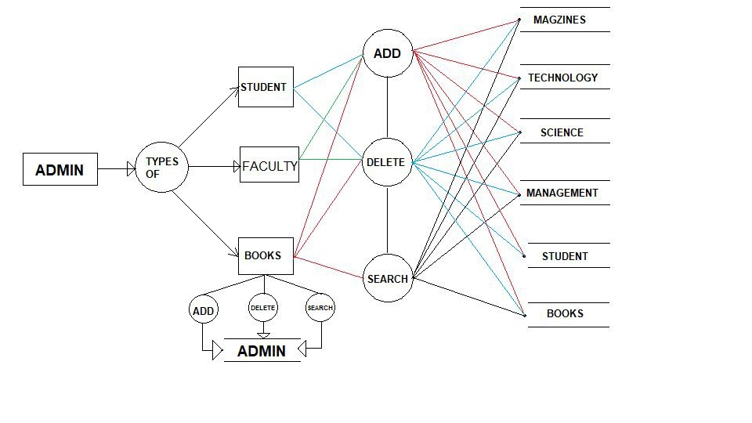

LIBRARYMANAGEMENTSYSTEM

CHAPTER- 3

SYSTEMANALYSIS&DESIGN

Systemanalysis and design deal with planning the development of information systems

through understandingandspecifyingindetail what asystemshoulddoandhowthecomponents

of the systemshould be implemented and work together. Systemanalysis and design to solve

business problems through analyzing the requirements of information systems and designing

suchsystems byapplyinganalysis anddesigntechniques.

Systemanalysis and design is the most essential phase in the development of a system

since the logical system design arrived at as a result of systems analysis which is in turn

convertedintophysical systemdesign.

3.1SYSTEMARCHITECTURE

Architectureof LibraryManagement System:

● Addor CreateStudents, Faculties andBooks details

● DeleteStudent andbooks details

● Returningbooks

● SearchBookcategory

Basicarchitectureof librarymanagement systemis givenbelow:

​Fig. 3.1: Architectureof libraryManagement System

DeptofCSE, RRIT 05 2019-2

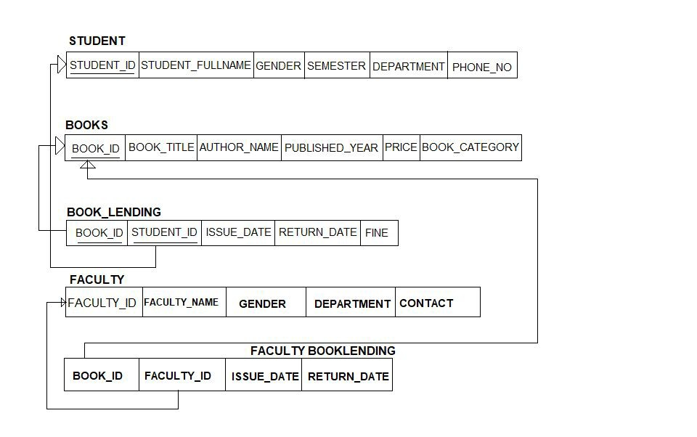

LIBRARYMANAGEMENTSYSTEM

3.2 SCHEMADIAGRAM

A schema contains schema objects, which could be tables, col​ u ​ mns​ , data types, views,​

storedprocedures, relationships​ , primarykeys, foreignkeys, etc.​

A database schema can be represented in a visual diagram, which shows the database

objects andtheir relationshipwitheachother.

SCHEMADIAGRAMFORLIBRARYMANAGEMENTSYSTEM:

​Fig. 3.2: SCHEMADiagramfor LibraryManagement System

DeptofCSE, RRIT 06 2019-20

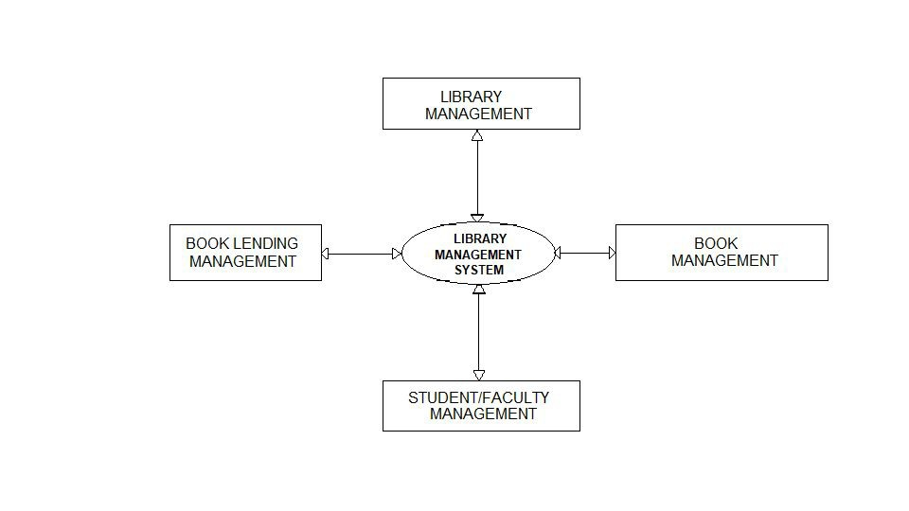

LIBRARYMANAGEMENTSYSTEM

3.3​ ​DATAFLOWDIAGRAMSOFLIBRARYMANAGEMENTSYSTEM

The proposed idea for the Library Management Systemwill be represented using data

flow diagrams. A data flow diagram(DFD) is a graphical representation of the "flow" of data

through an information system, modelling its process aspects. A DFD is often used as a

preliminary step to create an overview of the system, which can later be elaborated. DFDs can

alsobeusedfor thevisualizationof dataprocessing(structureddesign).

3.3.1DFDLevel 0of Initial Data

This is thezerolevel DFDof libraryManagement System, wherewehaveelaborated the

high level process of Library Management .Its a basic overview of the whole library

Management Systemor processed being analysedor modeled. It’s designedtobeanat-a-glance

viewof Student showingthesystemas asinglehigh-level process .

● Managingall thelibrary

● Managingall thebook

● Managingall theissuebook

● Managingall thestudent

● Managingall thefaculties

​Fig. 3.3.1: DFDLevel 0Of Initial State

DeptofCSE, RRIT 07 2019-20

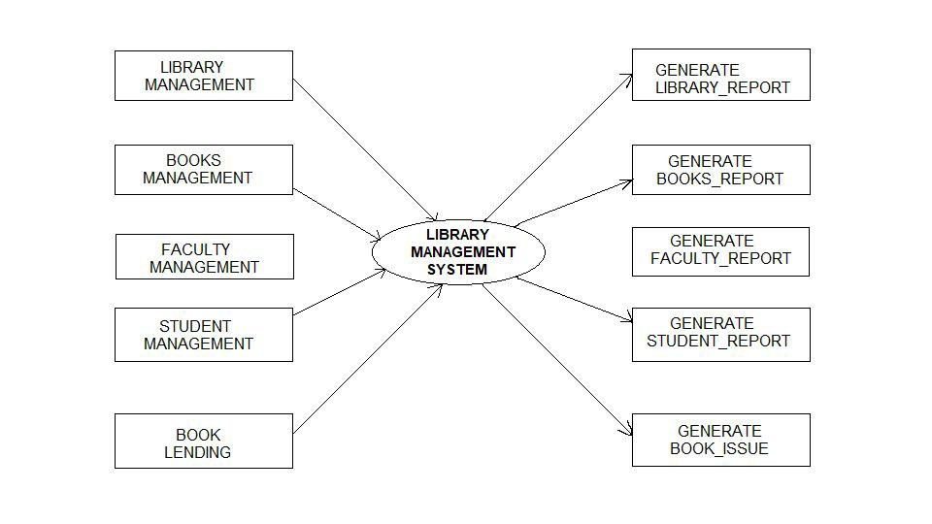

LIBRARYMANAGEMENTSYSTEM

3.3.2DFDLevel 1of MainPage

First Level DFD (1st Level) of Library Management systemshows howthe systemis divided

into sub-system(processes), each of which deals with one or more of the data flows to or from

an external agent, and which together provide all of thefunctionalityof thelibraryManagement

Systemas awhole. It alsoidentifies internal datastores of Student.

Mainentities andoutput of first level DFD(1st Level DFD):

1. ProcessingBookrecords andgenerateareport of all Book.

2. ProcessingIssuebookrecords andgenerateareport of all IssueBook.

3. ProcessingStudent records andgenerateareport of all Student.

3. ProcessingFacultyrecords andgenerateareport of all Faculties.

Fig. 3.3.2: DFDLevel 1Of MainPage

DeptofCSE, RRIT 08 2019-20

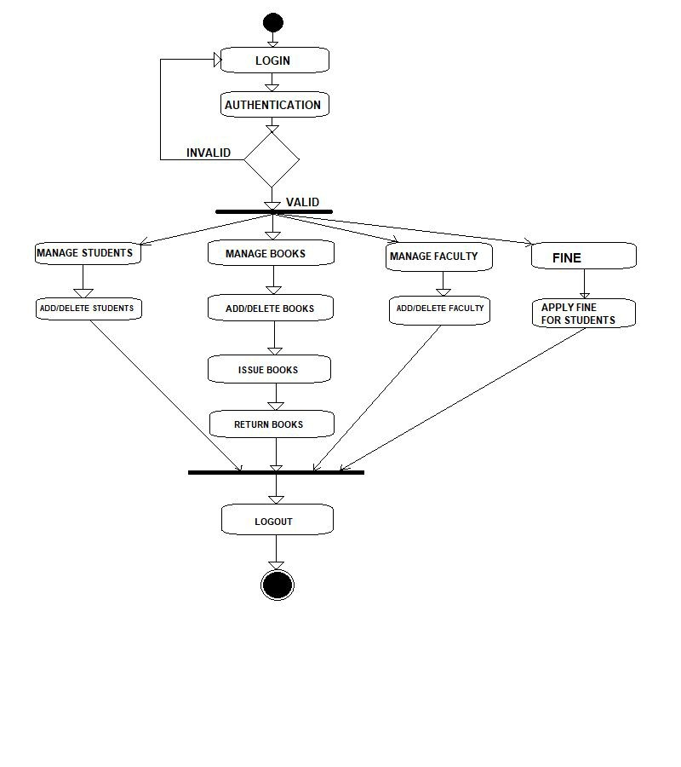

LIBRARYMANAGEMENTSYSTEM

3.4 ACTIVITYDIAGRAM

Activity diagramis defined as a UML diagramthat focuses on the execution and flow of the

behavior of a system instead of implementation. It is also called object-oriented flowchart.

Activity diagrams consist of activities that are made up of actions which apply to behavioral

modelingtechnology.

Fig. 3.4: ActivityDiagramfor LibraryManagement System

DeptofCSE, RRIT 09 2019-20

LIBRARYMANAGEMENTSYSTEM

3.5 ENTITY-RELATIONDIAGRAM

Entity-Relationship Diagram depicts the relationship between the various entities

involved. An entity is any real-world object. The attribute of each entity noted in the

entity-relationshipdiagramcanbedescribedusinganentitydescriptionas showninFig3.5

E-Rdiagramserves twopurposes:

● Toprovideanindicationof howdataaretransformedas theymovethroughthesystem.

● Todepict thefunctions that transformationthedataflow.

Entities

An entity or a data object is the representation of almost any compositeinformationthat

must be understood by the software. By composite information, we mean something that has a

number of different properties or attributes. A data object encapsulates data only. There is no

referencewithinadataobject tooperationthat act onthedata.

Attributes

Attributes define the properties of data objects and take on one of three different

characteristics. Theycanbeusedto:

Name an instance of object. Describe the instance. Make reference to another instance in the

table.

Entity-Set andKeys

Key is an attribute or collection of attributes that uniquely identifies an entity among

entityset.

For example, theroll_number of astudent makes him/her identifiableamongstudents.

Super Key− A set of attributes (one or more) that collectively identifies an entity in an entity​

set.

Candidate Key− Aminimal super key is called a candidate key. An entity set may havemore

thanonecandidatekey

PrimaryKey​−Aprimarykeyis oneof thecandidatekeys chosenbythedatabasedesigner to

uniquelyidentifytheentityset.

DeptofCSE, RRIT 10 2019-20

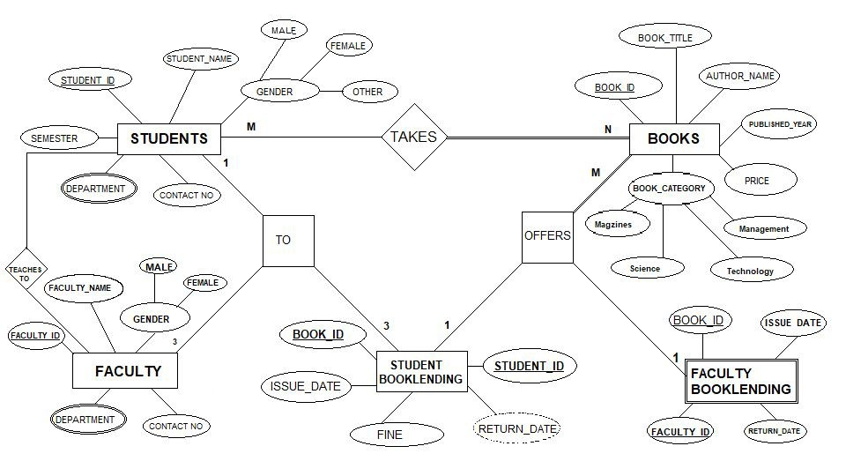

LIBRARYMANAGEMENTSYSTEM

Relationships

Entities areconnectedtooneanother andaredependent ononeanother for certaindata

transactions. This connectionis shownbymeans of arelationshipbetweentheentities involved.

Therelationshipis binaryif thenumber of participatingentities are2, ternaryif 3andm-aryif

m.

Examples of Relations:

1) Student / Facultytakes Books - M: N

2) Books offers BookLending- M: 1

3) BookLendingtoStudent - 3: 1

4) BookLendingtoFaculty- 3: 1

​Fig. 3.5: ERDiagramof LibraryManagement System

DeptofCSE, RRIT 11 2019-20

LIBRARYMANAGEMENTSYSTEM

3.6.1​ ​NORMALIZATION

Database normalization is the process of removing redundant data fromyour tables. In

order toimprovestorageefficiency, dataintegrity, and scalability. ​

Normalization generally involves splitting existing tables into multiple ones,which must

bere-joinedor linkedeachtime aqueryis issued. ​

3.6.11ST NORMALFORM:

Giventables is convertedtoits 1NFas follows:

● Eliminationof duplicativecolumns fromtable1​.

● Create separate tables for each group of related data and identify each rowwith unique

column(primarykey). ​

● create separate table for each group of related data and identify each row with unique​

column(primarykey) . ​

Tablefor1NF:

STUDENT_ID BOOK_ID ISSUE_DATE

11 101, 102, 103 21-JAN-2019

AFTER1NFINDATABASE:

STUDENT_ID BOOK_ID ISSUE_DATE

11 101 21-JAN-2019

11 102 21-JAN-2019

11 103 21-JAN-2019

​Fig. 3.6.1: 1st Normal Form

DeptofCSE, RRIT 12 2019-20

LIBRARYMANAGEMENTSYSTEM

3.6.22ND NORMALFORM:

● A table is in first normal formand each non-key field is functionality dependent upon

Primarykey

● ​It must not containanypartial dependency. ​

● Now we’ll take the table above and design new tables that will eliminate the repeated​

Dateinnokey_field.

➢ createatablefor thosefields andenter thesampledata​ . ​

BOOK_ID STUD_ID NAME BOOK_CATEGORY ISSUE_DATE RETURN_DATE

11 101 AAA FIRSTSEM 30-JAN-2019 17-FEB-2019

12 101 AAA SECONDSEM 21-FEB-2019 28-FEB-2019

13 102 BBB THIRDSEM 12-JUN-2019 20-JUN-2019

AFTER2NDNORMALFORM:

BOOK_ID STUD_ID NAME BOOK_CATEGORY

11 101 AAA FIRSTSEM

12 101 AAA SECONDSEM

13 102 BBB THIRDSEM

BOOK_ID BOOK_CATEGORY ISSUE_DATE

11 FIRSTSEM 30-JAN-2019

12 SECONDSEM 21-FEB-2019

13 THIRDSEM 12-JUN-2019

STUD_ID ISSUE_DATE RETURN_DATE

101 30-JAN-2019 17-FEB-2019

101 21-FEB-2019 28-FEB-2019

102 12-JUN-2019 20-JUN-2019

Fig. 3.6.2: 2ndNormal Form

DeptofCSE, RRIT 13 2019-20

LIBRARYMANAGEMENTSYSTEM

3.6.33RDNORMALFORM(3NF):

​Thirdnormal form(3NF) requires that there arenofunctional dependencyof non-key.

Attributes onsomethingother thanacandidatekey. ​

● A table is in 3NF if all of the non primary-key attributes are mutually​

independent. ​

● Thereshouldnot betransitivedependencies​.

➢createatablefor thosefields andenter thesampledata​ . ​

STUD_ID BOOK_ID NAME GENDER BOOK_CATEGORY

101 11 AAA MALE FIRSTSEM

101 12 AAA MALE SECONDSEM

102 13 BBB FEMALE THIRDSEM

AFTER3NF:

STUD_ID NAME GENDER

101 AAA MALE

101 AAA MALE

102 BBB FEMALE

BOOK_ID NAME BOOK_CATEGORY

11 AAA FIRSTSEM

12 AAA SECONDSEM

13 BBB THIRDSEM

Fig. 3.6.3: 3rdNormal Form

DeptofCSE, RRIT 14 2019-20

LIBRARYMANAGEMENTSYSTEM

CHAPTER- 4

RESULTS

ASingle user, usually the admin could successfully log-in by entering his usernameand

password which will lead to the main page or else if entered wrong password or username it

shows “invalidusernameor password”.

The main page provides links to different data such as students, books andbooklending

data where the admin could addanynewstudent databyprovidingparticulars of astudents such

as id, name, sem, department, gender, phone no., and press “submit”. Thestudent updateoption

could successfully search for the student details that needs tobeupdatedbytakingtheuniqueid

of student and the details of the student of given id no could be updated as desired. Thestudent

data of a particular student was deleted by givingtheidof student. All thesedetails of student is

showeduponstudent datatable.

The books table has an option as “add/delete”, which adds newbooks information such

as book_id, title, author_name, published_year, price and book_category given by the admin,

andpress “submit”. Thesedetails showedupinthebooks datatable.

The book_lending table has options to add, deleteandviewthebook_lendingdatathat is

entered. In the “book_lending” table the admin could enter the book_id, student_id and press

“submit”. After submitting the data, the table contains issue_date, return_date, and fine it will

take current date of the issue_date . The books data could be deleted in the delete option by

givingtheuniqueidof thebook. Thesedetails showedupinthebooks datatable.

After the actions the user could successfully log-out of the system. Thus, the above

features weretestedandis freefromdefects.

DeptofCSE, RRIT 15 2019-20

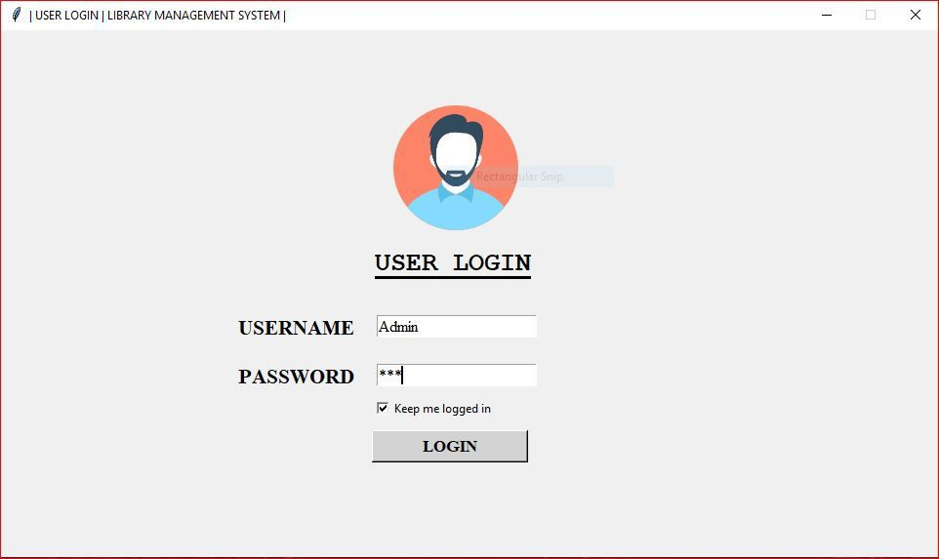

LIBRARYMANAGEMENTSYSTEM

​​4.1SNAPSHOTS

​Fig. 7.1.1: LoginPage

Loginpageallowsusertoenterusernameandpasswordforverificationpurposestokeepthe

softwaresafefromunauthorisedaccess.

DeptofCSE, RRIT 16 2019-20

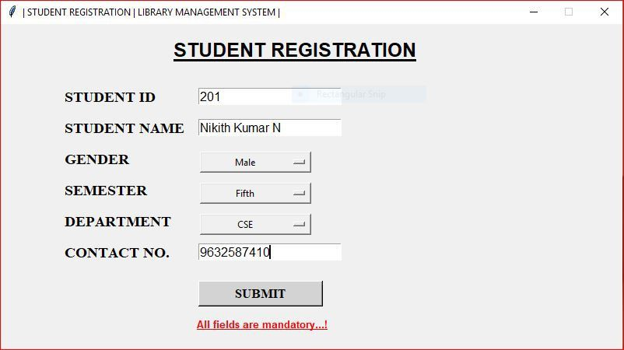

LIBRARYMANAGEMENTSYSTEM

​Fig. 7.1.2: MainPage​

Mainpageallowsaccesstodifferentdataandprovideslinktoaddnewdetailstothetables

​Fig. 7.1.3: StudentInformationInsertion

DeptofCSE, RRIT 17 2019-20

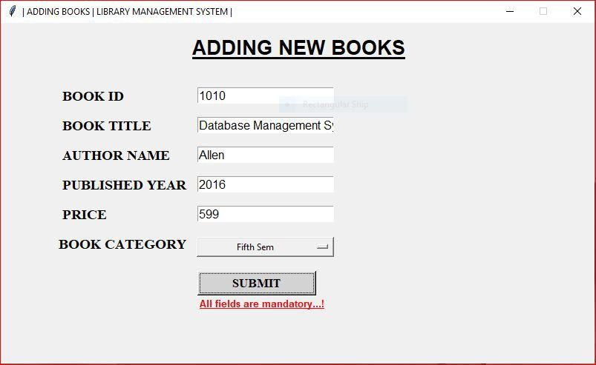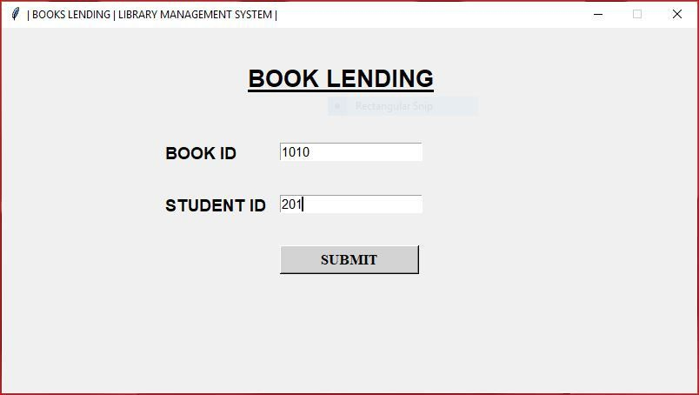

LIBRARYMANAGEMENTSYSTEM

​Fig. 7.1.4: BookDetails

Bookdetailsshowsdetailsthathavetobeaddedtobooktable

​Fig. 7.1.5: BookLendingDetails

BookLendingdetailsshowsdetailsthathavetobeaddedtobooklendingtable

DeptofCSE, RRIT 18 2019-20

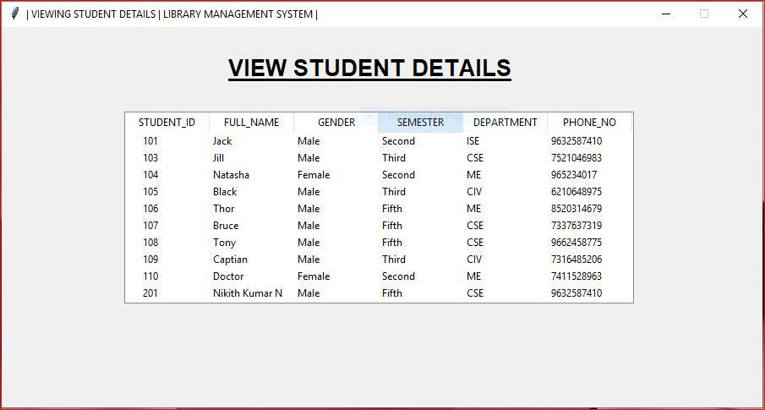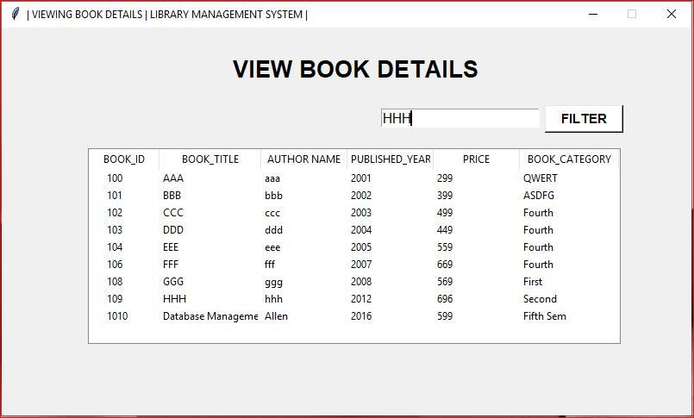

LIBRARYMANAGEMENTSYSTEM

Fig. 7.1.6: StudentDetails

Studentdetailspageshowsthedatathatmustbeenteredaboutthestudentinthelibrary

Fig.7.1.7: BooksDetails

Booksdetailspageshowsthedatathatmustbeenteredaboutthebooksinthelibrary

DeptofCSE, RRIT 19 2019-20

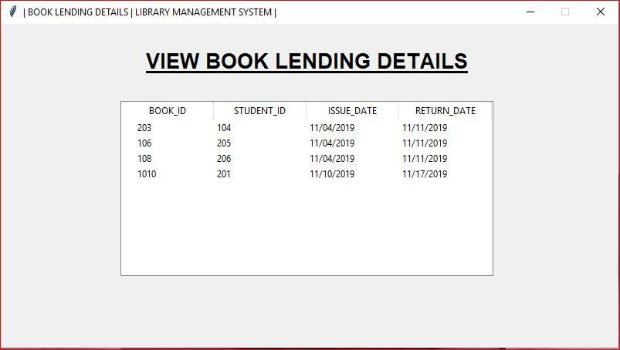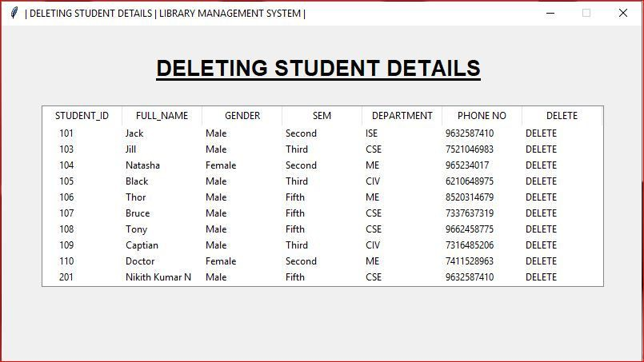

LIBRARYMANAGEMENTSYSTEM

Fig. 7.1.8: BooklendingDetails

BookLendingdetailspageshowsthedatathatmustbeenteredaboutthebooklendinginthe

library

Fig. 7.1.9: StudentDetailsDeletion

Studentdetailsdeletionpageshowsthedatathatmustbedeletedinthestudentdatabase.

DeptofCSE, RRIT 20 2019-20

LIBRARYMANAGEMENTSYSTEM

CONCLUSIONANDFUTUREENHANCEMENT

The systemhas been developed with much care that it is free of errors and at the same

time it is efficient and less time consuming. The important thing is that the systemis robust. It

avoids malfunction fromoutsiders. It goes throughall phases of softwaredevelopment cycle. So,

product is accurate. Also, provisionis providedfor futuredevelopments inthesystem.

The Library Management systemcanbeusedfor theproper functioningof thesanctuary.

It provides Information to the User about the library system, through which he/she can borrow

books from the library. The library systemallows student to borrow only 3 books at once, if

he/she takes more than 3 books the systemshowerror message ie; (This student_id has taken 3

books please return back and borrowanother on). This systemcalculates fine for book lending

after the date exceeds ie; 7days fromissuedate, if returndateis expiredit calculates per day2Rs

automatically. After all theoperationis over theadmincanlogout fromthesystem.

Further enhancements to the websites can be made, making it more user friendly, more

innovation can be brought out, instead of sticking into fixedboundaries. This applicationcanbe

easily implemented under various situations. We can add newfeatures as and when we require.

Reusability is possible as and when required in this application. There is flexibility in all the

modules

DeptofCSE, RRIT 21 2019-2

LIBRARYMANAGEMENTSYSTEM

REFERENCES

Websites:

[1] W3Schools, TkinterTutorials:http://www.w3schools.com​

[2] GoogleChrome

[3] Youtube

[4]h ​ ttp://www.stackoverflow.com

[5] url ='h ​ ttps://docs.python.org/3.3/library/tk.html' ​

[6] url =‘h ​ ttps://pythonprogramming.net/python-3-tkinter-basics-tutorial’ ​

[7] Tkintervideos:https://youtu.be/e3i5tMxmcxk​

DeptofCSE, RRIT 22 2019-20

LIBRARYMANAGEMENTSYSTEM

APPENDIX

SOURCECODE

● CodeforfrontendAdminLoginPage

#Thisistheloginpageof LibraryManagementSystem..

fromtkinter import*

importThirdPage

fromPILimportImageTk, Image

importtkinter.messageboxasnk

classMainWindow:

def __init__(self):

self.win=Tk()

#windowbackgroundcolor usingcanvas

self.canvas=Canvas(self.win, width=960, height=540, bg='white')

self.canvas.pack(expand=YES, fill=BOTH)

#showwindowinthecenter of thescreen

width=self.win.winfo_screenwidth()

height=self.win.winfo_screenheight()

x=int(width/2- 960/2)

y=int(height/2- 540/2)

str1 ="960x540+" +str(x) +"+" +str(y)

self.win.geometry(str1)

#disableresizewindow

self.win.resizable(False, False)

#changingthetitleof thewindow

self.win.title("| USERLOGIN| LIBRARYMANAGEMENTSYSTEM|")

DeptofCSE, RRIT 23 2019-20

LIBRARYMANAGEMENTSYSTEM

def add_frame(self):

self.frame=Frame(self.win, height=540, width=960)

self.frame.place(x=0, y=0)

self.image=

ImageTk.PhotoImage(Image.open("C:\\Users\\Nikith\\PycharmProjects\\Bolt2.py\\images

\\man.png"))

self.label =Label(self.frame, image=self.image)

self.label.place(x=400, y=75)

#creatingloginformfor onlyadmincanaccess

self.label =Label(self.frame, text="USERLOGIN")

self.label.config(font=("Courier", 20, 'underlinebold'))

self.label.place(x=380, y=220)

#creatingusernamelabel andentryfield

self.label1 =Label(self.frame, text="USERNAME")

self.label1.config(font=("Times", 16, 'bold'))

self.label1.place(x=240, y=290)

self.user =Entry(self.frame, font="Times12")

self.user.place(x=385, y=292)

#creatingpasswordlabel andentryfield

self.label2=Label(self.frame, text="PASSWORD")

self.label2.config(font=("Times", 16, 'bold'))

self.label2.place(x=240, y=340)

self.pswd=Entry(self.frame, font="Times12", show="*")

self.pswd.place(x=385, y=342)

self.checkbox=Checkbutton(self.frame, text="Keepmeloggedin").place(x=380,

y=375)

self.btn=Button(self.frame, text='LOGIN', width=15, bg='lightgrey', fg='black',

font=("Times", 13, "bold"),

command=self.login

DeptofCSE, RRIT 24 2019-2​0

LIBRARYMANAGEMENTSYSTEM

self.btn.place(x=380, y=410)

def login(self):

data=(

self.user.get(),

self.pswd.get()

)

#if elseconditionfor user authenticate..!

if self.user.get() =="Admin" andself.pswd.get() =="160698":

nk.showinfo("Logininfo", "WelcomeTo\nLibraryManagementSystem...!")

self.win.destroy()

t=Thirdpage.ThirdWindow()

t.add_menu()

t.add_frame()

else:

nk.showinfo("Loginerror", "InvalidUsername&Password")

self.win.mainloop()

DeptofCSE, RRIT 25 2019-20

LIBRARYMANAGEMENTSYSTEM

● Codeforbackenddatabase

importsqlite3

importdatetime

#Creatingandinsertingstudentdetails..!

def StudentReg(data):

conn=sqlite3.connect("Library.db")

cur =conn.cursor()

cur.execute(

'CREATETABLEIFNOTEXISTSStudent("STUDENT_ID" INTEGERUNIQUE,

"FULL_NAME" TEXT, "GENDER" TEXT, '

'"SEM" TEXT, "DEPARTMENT" TEXT, "PHONENO" INTEGER, PRIMARYKEY("STUDENT

ID"))')

cur.execute('INSERTINTOStudentVALUES(?,?,?,?,?,?)', data)

conn.commit()

#Creatingandinsertingbookdetails..!

def AddBook(data):

conn=sqlite3.connect("Library.db")

cur =conn.cursor()

cur.execute(

'CREATETABLEIFNOTEXISTSBooks("BOOK_ID" INTEGER, "BOOK_TITLE" TEXT,

"AUTHOR_NAME" TEXT, '

'"PUBLISHED_YEAR" INTEGER, "PRICE" INTEGER, PRIMARYKEY("BOOK_ID"))')

cur.execute('INSERTINTOBooksVALUES(?,?,?,?,?)', data)

conn.commit()

#Creatingandinsertingbookdetails..!

def BookLending(data, id):

status=0

id_status=0

print(data, type(data[3]))

conn=sqlite3.connect("Library.db")

cur =conn.cursor()

DeptofCSE, RRIT 26 2019-20

LIBRARYMANAGEMENTSYSTEM

cur.execute(

'CREATETABLEIFNOTEXISTSBookLending("BOOK_ID" referencesBooksonDELETE

CASCADE, "STUDENT_ID"'

'referencesStudentonDELETECASCADE, "ISSUE_DATE" INTEGER,"RETURN_DATE"

INTEGER, "FINE" INTEGER, '

'PRIMARYKEY("BOOK_ID", "STUDENT_ID"))')

cur.execute('SELECTCOUNT(*) FROMBookLendingB, StudentSwhereB.STUDENT_ID=

?andS.STUDENT_ID=?', id)

id_count=cur.fetchone()

print(type(id_count), id_count[0])

if id_count[0] <=2:

id_status=1

cur.execute('INSERTINTOBookLendingVALUES(?,?,?,?,0)', data)

else:

id_status=0

status=1

conn.commit()

returnint(status), int(id_status)

def ViewStudents():

conn=sqlite3.connect("Library.db")

cur =conn.cursor()

cur.execute("SELECT*FROMStudent")

returncur.fetchall()

def ViewBooks():

conn=sqlite3.connect("Library.db")

cur =conn.cursor()

cur.execute("SELECT*FROMBooks")

returncur.fetchall()

def BookLend():

conn=sqlite3.connect("Library.db")

cur =conn.cursor()

cur.execute("SELECT*FROMBookLending")

returncur.fetchall()

DeptofCSE, RRIT 27 2019-20

LIBRARYMANAGEMENTSYSTEM

def DeleteStudent(data):

conn=sqlite3.connect("Library.db")

cur =conn.cursor()

cur.execute('DELETEFROMStudentWHERESTUDENT_ID=?', data)

conn.commit()

returnTrue

def Update(data):

conn=sqlite3.connect("Library.db")

cur =conn.cursor()

cur.execute('UPDATEBooksSETBOOK_ID=?, BOOK_TITLE=?, AUTHOR_NAME=?,

PUBLISHED_YEAR=?, PRICE=?WHERE'

'BOOK_ID=?', data)

conn.commit()

returnTrue

def Delete(data):

conn=sqlite3.connect("Library.db")

cur =conn.cursor()

cur.execute('DELETEFROMBooksWHEREBOOK_ID=?', data)

conn.commit()

returnTrue

def Return(data):

conn=sqlite3.connect("Library.db")

cur =conn.cursor()

print(data)

date_format="%m/%d/%Y"

today=datetime.date.today()

current_date=str(today.strftime("%m/%d/%Y"))

print(type(current_date))

cur.execute('selectreturn_datefromBookLendingwherebook_id=?andstudent_id=

?', data)

return_date=cur.fetchone()

fine_days=(datetime.datetime.strptime(current_date, date_format) -

datetime.datetime.strptime(return_date[0], date_format)).total_seconds() /60/60/24

fine_days=int(fine_days)

DeptofCSE, RRIT 28 2019-20

LIBRARYMANAGEMENTSYSTEM

cur.execute("deletefromBookLendingwherebook_id=?andstudent_id=?", data)

print(fine_days)

if fine_days<=0:

fine_days=0

conn.commit()

returnTrue, fine_days

DeptofCSE, RRIT 29 2019-20